NIM: 2311104034
Nama: Maulana Kaka Halin Widyadhana
Kelas: SE-07-01
Wordpress
Link: https://kirayoshikage.lovestoblog.com/
Halaman 1
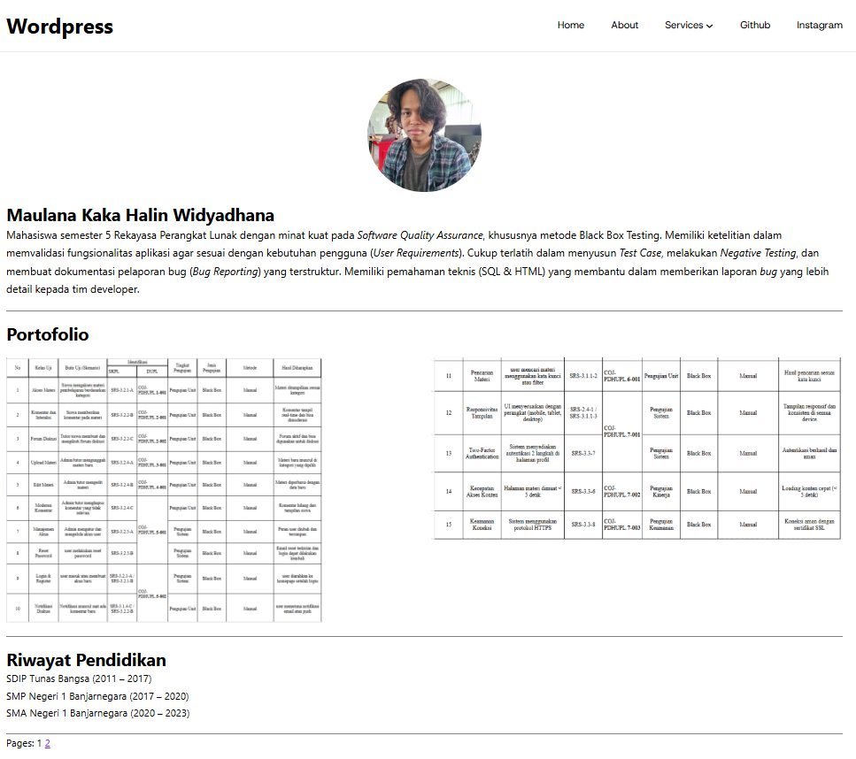

Halaman 2
